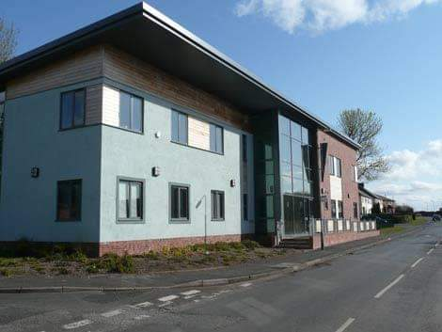

**It’s called the**

**Patient Participation Group**

**and it needs people like you to join.**

**If you’re interested ring or see one of the receptionists and they’ll get someone to chat with you about it. Tel. 01228791328**

**There’s a group set up for patients and the Practice to work together to meet each others needs**

**I didn’t know that. Sounds interesting**

**Yes, but how could I do that?**

**Would you like to be able to influence what happens there?**

**Are you interested in the services provided at the Practice?**

**Yes**

# **Longtown Medical Practice**

# 01228 791328